Queen’s Engineering Society IT Team

Forum Styling Guide

# Primary Colours

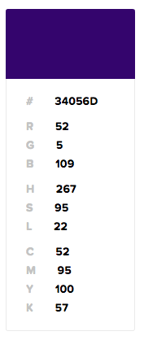 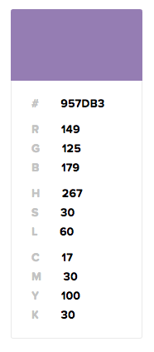 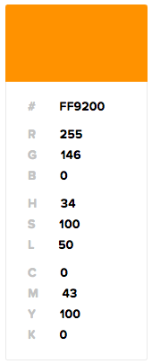 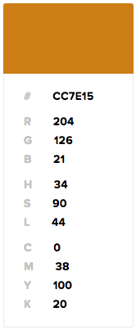

# Typography

The font used on the entire website is *Comfortaa*. It is a font imported from Google Fonts and there are two font weights used: 400 and 700.